**Towards Trustworthy Digital Twins in Healthcare:**

**VVUQ Activities in the GEMINI Project**

Karol Zając1, Piotr Nowakowski1,2, Marek Kasztelnik2, Piotr Połeć2, Marian Bubak1,2

1Sano Centre for Computational Medicine, Czarnowiejska 36, 30-054 Kraków, Poland  
2ACC Cyfronet AGH, Nawojki 11, 30-950 Kraków, Poland  
{k.zajac,*p.nowakowski,m.bubak*}@*sanoscience.org,* {*m.kasztelnik,p.polec*}@*cyfronet.pl*

**Keywords:** Digital Twin, VVUQ, Personalized Healthcare, Modelling and Simulation, HPC

1. Introduction

Digital twins hold great promise for transforming modern healthcare by enabling predictive, individualized simulations that inform diagnosis and treatment. In this context, the GEMINI project [1] aims to create a new generation of multi-scale digital twins for patients suffering from ischemic and hemorrhagic stroke. A critical pillar of the project is ensuring the reliability and credibility of these digital models, particularly in clinical settings where robust decisions depend on model quality.

1. Description of the problem

While high-fidelity models exist for various physiological systems, their translation into digital twin systems requires rigorous testing to guarantee validity. In complex simulations, errors can arise from numerical methods, parameter uncertainty, or model assumptions. The **Verification, Validation, and Uncertainty Quantification (VVUQ) [2]** processes are therefore essential for assessing model credibility and quantifying confidence in their predictions, especially when models influence therapeutic decisions.

1. Related work

The need for systematic VVUQ processes is increasingly recognized within the digital twin community, including in projects like In Silico World [3] or EDITH [4]. However, many existing pipelines still struggle with scalability and reproducibility, especially when faced with new use cases or when applied to large patient cohorts and HPC environments. Sano, in GEMINI, aims to bridge this gap by integrating modular and scalable VVUQ workflows directly into its simulation framework.

1. Solution to the problem

As part of the project, Sano leads a dedicated effort to design and implement a VVUQ methodology aligned with the overall GEMINI digital twin pipeline. This includes:

* Implementation of automation tools (e.g., EasyVVUQ [5] and Dask [6]) for running large-scale uncertainty and sensitivity analyses [Fig.3].
* Integration with HPC platforms (via SLURM, MPI, Dask) for scalable deployment across thousands of simulations [Fig.2].
* Tracking and storing simulation metadata, reproducibility, and versioning (Model Execution Environment [7]) [Fig.1]. to comply with future certification standards.

Multiple generic execution solutions have been proposed to manage simulation runs across multiple models and patient cohorts, supporting reproducible VVUQ experimentation.

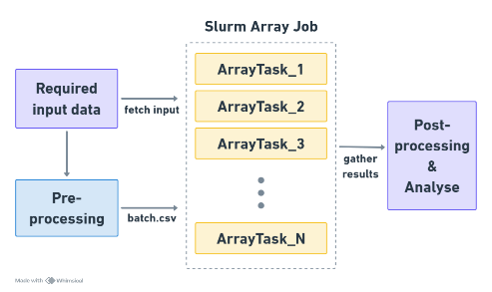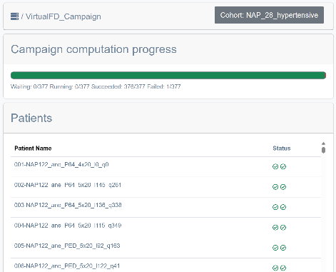

**Fig.2.** Massively parallel study diagram using SLURM array job.

**Fig.1.** MEEcampaign management view for a cohort of patients.

**Fig.3.** General workflow diagram for UQ/SA experiments using EasyVVUQ and Dask.

1. Conclusions and future work

Sano’s work in GEMINI lays the foundation for trustworthy and certifiable medical digital twins. By embedding reproducible VVUQ workflows into the digital twin lifecycle and validating them on stroke-related models, we contribute a critical building block for future clinical adoption. The next steps involve tighter integration with clinical and data partners, further automation, and simulation workflow optimization.

Acknowledgements. We acknowledge the support of EU under grants GEMINI No. 101136438, as well as ACC Cyfronet AGH for providing computer facilities and support within computational grant No. PLG/2024/017108 and PLG/2025/018168.

References

1. GEMINI - *A Generation of Multi-scale Digital Twins of Ischaemic and Haemorrhagic Stroke Patients*, EU Project, Horizon, <https://dth-gemini.eu/>
2. D. Suleimenova et al, *Tutorial applications for Verification, Validation and Uncertainty Quantification using VECMA toolkit*, Journal of Computational Science, vol. 53, Jul. 2021. <https://doi.org/10.1016/j.jocs.2021.101402>
3. In Silico World - *Lowering the barriers to a universal adoption of In Silico Trials*, EU Project, Horizon, <https://insilico.world/>
4. EDITH – *European Virtual Digital Twin,* EU Project, Digital Europe, <https://www.edith-csa.eu/>;
5. Dask Distributed documentation web site: https://distributed.dask.org/en/stable/
6. EasyVVUQ: Uncertainty intervals for everyone: <https://easyvvuq.readthedocs.io/en/dev/>
7. M. Kasztelnik, P. Nowakowski, J. Meizner, M. Malawski, A. Nowak, K. Gadek, K. Zajac, A. A. L. Mattina, and M. Bubak, *Digital twin simulation development and execution on hpc infrastructures*, Computational Science – ICCS 2023, pp. 18–32, 2023. <https://doi.org/10.1007/978-3-031-36021-3_2>