Application of Deep Learning to Quantify Brain Microstructure
Dominika Ciupek¹, Maciej Malawski^{1,2}, Tomasz Pięciak^{3,1}
¹Sano Centre for Computational Medicine, Czarnowiejska 36, 30-054 Kraków, Poland
²AGH University of Kraków, Al. Mickiewicza 30, 30-059 Kraków, Poland
³ETSI Telecomunicación, Universidad de Valladolid, Paseo de Belén 15, 47011 Valladolid, Spain
{d.ciupek,m.malawski}@sanoscience.org, tpieciak@tel.uva.es
Keywords: diffusion-weighted magnetic resonance imaging, multicompartment models, deep learning
- Introduction
Diffusion-weighted magnetic resonance imaging (DW MRI) offers valuable insights into cellular structures, making it a powerful tool for the non-invasive evaluation of brain microstructure. This modality is particularly sensitive to natural processes of brain maturation and aging, and various neurological disorders [1]. However, accurate modeling of the DW signal is crucial for extracting quantitative indicators, especially when the acquisition procedure is limited.
- Description of the problem
Diffusion tensor imaging (DTI) [2] is a widely used technique for modeling the DW signal, but interpreting its data can be challenging as it only captures the primary direction of diffusion [1]. An alternative approach involves using multicompartment biophysical models that assume specific tissue geometries and can directly estimate key microstructural parameters, making data interpretation easier [3]. Two of the most popular biophysical models are Neurite Orientation Dispersion and Density Imaging (NODDI) [4] and the Spherical Mean Technique (SMT) [5] (see Fig.1). Microstructural parameters derived from multicompartment models are typically calculated using numerical optimization procedures. However, these methods require more complex and time-consuming acquisition protocols, including a specific number of DW volumes, than those commonly used in clinical practice. This complexity significantly limits the practical application of biophysical models in clinical settings.

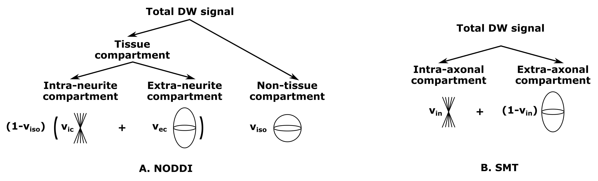
Fig.1. Distribution of the total DW signal between different compartments of the A. NODDI and B. SMT models.
- Related work
Research in the literature has explored the potential application of deep learning to estimate parameters of multicompartment models, especially the NODDI [6,7]. However, these studies are quite limited in scope. They often focus only on the effects of a reduced number of DW volumes, while employing acquisition schemes that are not commonly used in clinical practice.
- Solution to the problem
The study utilized the HCP WU-Minn data [8], which originally included 90 gradient directions for three b-values (1000, 2000, and 3000 s/mm²). To simulate acquisition protocols more representative of clinical settings [9], the data were downsampled and interpolated using spherical harmonics to generate three separate datasets with b = 1000 s/mm² and 32, 15, and 6 gradient directions. Microstructural parameters were estimated using both traditional numerical optimization techniques and a deep learning-based U-net model. Parameters derived from the original, full-resolution acquisition were used as the ground truth for comparison. Performance evaluation was conducted using the Mean Structural Similarity Index Measure (MSSIM).
A summary of the results is provided in Table 1.
Table 1. MSSIM results of the U-Net and a standard numerical method across different acquisition schemes, assessed for various parameters of the SMT and NODDI models.
 | 32 volumes, b1000 |  | 15 volumes, b1000 |  | 6 volumes, b1000
Microstructural parameter | DL model | Numerical method | DL model | Numerical method | DL model | Numerical method
v_{ic} | 0.950 | 0.703 | 0.947 | 0.704 | 0.945 | 0.698
v_{ec} | 0.785 | 0.099 | 0.791 | 0.103 | 0.784 | 0.116
v_{iso} | 0.884 | 0.484 | 0.887 | 0.488 | 0.867 | 0.495
v_{in} | 0.833 | 0.225 | 0.823 | 0.218 | 0.823 | 0.065
- Conclusions and future work
Deep learning models significantly outperform traditional numerical method, achieving MSSIM values over 0.8 for all parameters except v_{ec}, even with only 6 gradient directions.
To better assess ability of artificial intelligence to estimate microstructural parameters, we should move beyond U-Net to more advanced models like GANs, and focus on metrics more clinically relevant than MSSIM, particularly in key regions of the brain. It's also crucial to determine if these models can effectively differentiate parameter values between healthy individuals and those with diseases to support accurate diagnosis.
Acknowledgements. The numerical experiment was possible through computing allocation on the Ares and Athena systems at ACC Cyfronet AGH under the grant PLG/2025/018009. This work is supported by the European Union’s Horizon 2020 research and innovation programme under grant agreement No 857533 and the International Research Agendas Programme of the Foundation for Polish Science No MAB PLUS/2019/13. This publication was created within the project of the Minister of Science and Higher Education "Support for the activity of Centers of Excellence established in Poland under Horizon 2020" on the basis of the contract number MEiN/2023/DIR/3796. Tomasz Pieciak acknowledges the NAWA for grant PPN/BEK/2019/1/00421 and the Ministry of Science and Higher Education under the scholarship for outstanding young scientists (692/STY/13/2018).
References
- L. J. O’Donnell, et al.: An introduction to diffusion tensor image analysis, Neurosurgery clinics 22(2), 185-196, 2011.
- P. J. Basser, et al.: MR diffusion tensor spectroscopy and imaging, Biophysical journal 66(1), 259-267, 1994.
- I. O. Jelescu, et al.: Design and validation of diffusion MRI models of white matter, Frontiers in physics 5, 61, 2017.
- H. Zhang, et al.: NODDI: practical in vivo neurite orientation dispersion and density imaging of the human brain, Neuroimage 61(4), 1000-1016, 2012.
- E. Kaden, et al.: Quantitative mapping of the per‐axon diffusion coefficients in brain white matter, Magnetic resonance in medicine 75(4), 1752-1763, 2016.
- E. K. Gibbons, et al.: Simultaneous NODDI and GFA parameter map generation from subsampled q‐space imaging using deep learning, Magnetic resonance in medicine 81(4), 2399-2411, 2019.
- A. Faiyaz, et al.: Single‐shell NODDI using dictionary‐learner‐estimated isotropic volume fraction, NMR in biomedicine 35(2), 2022
- D. C. Van Essen, et al.: The WU-Minn human connectome project: an overview, Neuroimage 80, 62-79, 2013.
- M. D. C. Valdés Hernández, et al.: Rationale, design and methodology of the image analysis protocol for studies of patients with cerebral small vessel disease and mild stroke. Brain and behavior 5(12), 2015.

