**Advancing quality assurance of ion beam radiotherapy for cancers**

Mateusz Wójcik1,3, Leszek Grzanka1,2, Jeppe Brage Christensen3

1 AGH University of Krakow, al. Mickiewicza 30, 30-059 Kraków, Poland

2 IFJ PAN, Radzikowskiego 152, 31-342 Kraków, Poland

3 Paul Scherrer Institute, Forschungsstrasse 111, 5232 Villigen, Switzerland

[{](mailto:%7bmwojci@stuent.agh.edu.pl)mwojci@student.agh.edu.pl, [leszek.grzanka@ifj.edu.pl](mailto:leszek.grzanka@ifj.edu.pl), [jeppe.christensen@psi.ch](mailto:jeppe.christensen@psi.ch)}  
  
**Keywords**: HPC, medical simulation, ion chamber, particle therapy, recombination

1. Introduction

Radiotherapy has been a key component in cancer treatment for more than 100 years. Beyond conventional radiotherapy with photons, therapy with ions, known as particle therapy [3], is increasing worldwide. Furthermore, the emerging concept of ultra-high dose rate (UHDR) radiotherapy, or FLASH, offers the potential for an even greater reduction in radiation-induced toxicities. Prior to all therapies with particles, a thorough quality assurance is conducted with ionisation chambers. Measurements that rely on multiple corrections, including so-called ion recombination.

1. Description of the problem

Ionization chambers are considered the gold standard for determining dose in clinical and experimental settings, as they measure ionizing radiation by collecting charges produced in the medium [6]. A major challenge arises because some ions recombine before collection, thereby reducing the measured charge. The recombination correction factor must therefore be accurately determined to ensure a correct treatment of the patient.

Analytical theories describing this effect were developed in the 20th century, primarily by Jaffé [2] and later extended by Boag. While these models work well at low dose rates—where the recombination factor is below 1 %—at higher dose rates the factor may drop by up to 50%. In such cases, analytical theory fails to provide accurate corrections. To tackle this long-standing challenge and enable precise determination of ion recombination correction factors, we introduce the first dedicated numerical toolkit that leverages modern, state-of-the-art computational methods to faithfully solve the underlying physics.

1. Related work

Research in this direction has been motivated by the FLASH initiative, as UHDR radiotherapy moves toward clinical translation. Our toolkit IonTracks is a direct continuation of prior work [1], but introduces a fundamentally different simulation strategy, allowing more detailed modeling of recombination and transport phenomena. Other studies rely on techniques that cannot account for the high ionisation density within particle therapy tracks.

1. Solution to the problem

The implementation leverages the open-source FEniCS project [5], enabling efficient numerical solutions of partial differential equations (PDEs) relevant to charge transport and recombination. Python-based front-end code provides ease of use, while C++ back-end libraries deliver high computational performance. A dedicated abstraction layer allows users to flexibly modify simulation parameters without editing source code. Considerable effort was devoted to ensuring numerical stability and minimizing computational errors. Various meshing strategies were tested using gmsh [4], from uniform to adaptive approaches, and results were visualized with ParaView. The software is designed to efficiently utilize multi-threaded execution, enabling both seamless use on personal computers and scalable performance on HPC machines such as Ares.

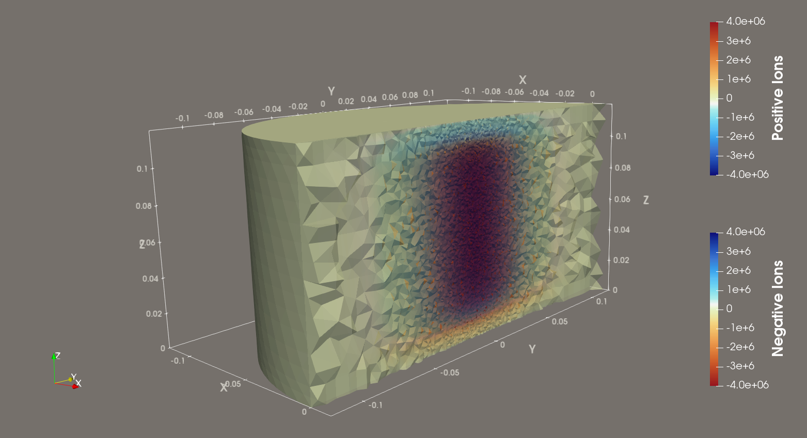

Fig.1. Example simulation of a parallel plate ionisation chamber (yellow) where the charge carriers (red and blue) from an ion track have been simulated.

1. Conclusions and future work

This computational framework strengthens the accuracy of ionization chamber measurements for quality assurance in heavy ion beam applications, thereby supporting the increasing global implementation of ion beam therapy in cancer treatment.

The next step will be to extend the simulation framework to support so-called MR-guided linacs, which still remains an unsolved problem, as the magnetic field impacts the movements of the charged carriers.

**Acknowledgements**. We acknowledge the support of EU: [Traceable dosimetry for FLASH radiotherapy](https://flash-dose.eu/)://flash-dose.eu/, as well as ACK Cyfronet AGH for providing computer facilities and support within computational grant no. PLG/2025/018530.

References

1. J. Christensen, N. Bassler, A general algorithm for calculation of recombination losses in ionization chambers exposed to ion beams, *Med.Phys.* 43 (2016) 5484
2. G. Jaffé, “Zur theorie der ionisation in kolonnen,” Ann. Phys. 347(12), 303–344 (1913)
3. Chen Z, Dominello MM, Joiner MC, Burmeister JW. Proton versus photon radiation therapy: A clinical review.
4. [Geuzaine and J.-F. Remacle. *Gmsh: a three-dimensional finite element mesh generator with built-in pre- and post-processing facilities*. International Journal for Numerical Methods in Engineering 79(11), pp. 1309-1331, 2009](https://gmsh.info/doc/preprints/gmsh_paper_preprint.pdf)
5. I. A. Baratta, J. P. Dean, J. S. Dokken, M. Habera, J. S. Hale, C. N. Richardson, M. E. Rognes, M. W. Scroggs, N. Sime, and G. N. Wells. DOLFINx: The next generation FEniCS problem solving environment, *preprint* (2023).