**Enhancing neutron measurement techniques for heavy ion beam cancer therapy**

Rafał Sawczyszyn1,2, Leszek Grzanka1,3, Jeppe Brage Christensen2

1AGH University of Krakow, al. Adama Mickiewicza 30, 30-059 Krakow, Poland

2Paul Scherrer Institute, Forschungsstrasse 1111, 5232 Villigen, Switzerland

3IFJ PAN, Walerego Eljasza-Radzikowskiego 152, 31-342 Krakow, Poland  
rsawczyszyn@student.agh.edu.pl, jeppe.christensen@psi.ch, leszek.grzanka@ifj.edu.pl

1. Introduction

In particle therapy, precise dose delivery is essential for treatment efficacy and patient safety. Global use of proton and carbon ion therapy has risen rapidly, with over 300,000 patients treated [1]. However, therapeutic ion beams generate secondary neutrons that can deposit dose far from the target. Even low neutron exposures may increase long-term cancer risk, particularly in sensitive groups such as children and pregnant patients. This makes it particularly difficult to use radiation therapy with heavy ions to treat a tumor in the vicinity a critical organ or near the stomach of a pregnant patient.

1. Description of the problem

There does not yet exist a neutron detector to measure the neutron doses, which can be placed e.g. on the stomach of a pregnant patient. However, one candidate is track-etched detectors (CR-39), originally developed for neutron dosimetry in nuclear plants but the analysis algorithms—largely unchanged for 50+ years—lack modern computational methods and are highly sensitive to defects, noise, and damage. Machine learning offers the potential to greatly improve TED analysis, providing the accuracy and robustness needed for safe clinical implementation in particle therapy. We aim to improve the old detector system with modern machine learning to improve the patient safety during radiotherapy.

1. Related work

Recent studies in this field were carried out in 2025 in the United States. Machine learning was applied to the analysis of particles produced in deuterium–deuterium fusion reactions [3]. Specifically, scans from CR-39 detectors were analyzed using a compact neural network based on Ultralytics’ YOLOv8 architecture. As a result, the network was able to successfully identify tracks left by proton and helium particle impacts. Different studies showed that machine learning methods can have high precision in track detection [4] [5].

1. Solution to the problem

To improve precision, we employed Mask R-CNN (Mask Region-based Convolutional Neural Network), introduced in 2017 by Facebook AI Research [2]. Mask R-CNN is a deep learning model designed for instance segmentation, meaning it can detect, classify, and separate individual objects within an image. By applying this approach to detector scans, the network can more accurately distinguish meaningful structures from defects or noise, significantly improving the reliability of the analysis. Our dataset consists of approximately 12,000 detector scans, each corresponding to known radiation doses. Neural network is trained on PLGrid High Performance Computing cluster (HPC) - Athena. This allows us to rigorously evaluate the network’s accuracy and identify possible improvements in detection performance.

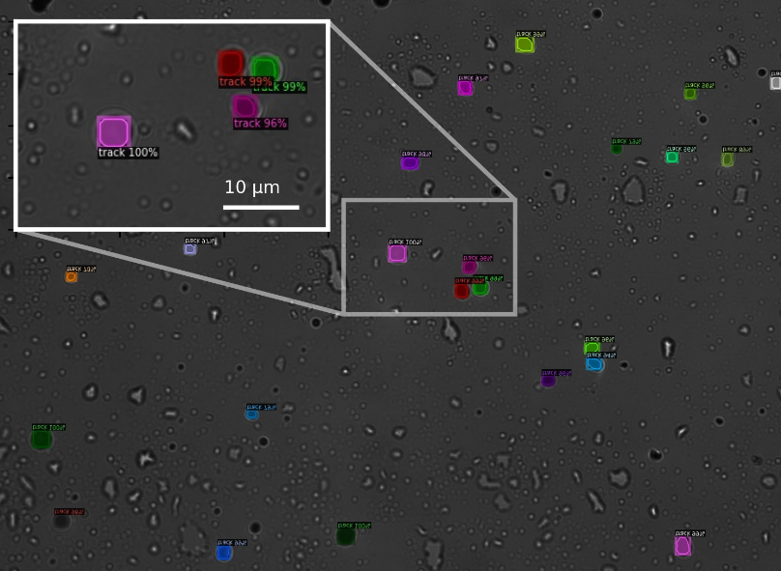

Fig. 1. Tracks detected on a heavily damaged CR-39 detector using Mask R-CNN.

1. Conclusions and future work

The current approach is effective, allowing us to identify over 85% of the tracks in an image. This means that a therapy plan with heavy ions can be experimentally validated, when the images are evaluated with the developed algorithm. In turn, this may reveal if a treatment will cause a large neutron dose to a critical region such as the stomach of a pregnant patient.

Future work will focus on further optimizing these elements, expanding the dataset with more diverse detector scans, and refining the network architecture to improve precision and robustness in detecting particle tracks.

We gratefully acknowledge Polish high-performance computing infrastructure PLGrid (HPC Center: ACK Cyfronet AGH) for providing computer facilities and support within computational grant no. PLG/2025/018530

**References**

1. Particle Therapy Co-Operative Group (PTCOG). (2025). PTCOG statistics. Retrieved from [https://www.ptcog.site/images/Statistics/](https://www.ptcog.site/images/Statistics/?utm_source=chatgpt.com)
2. He, K., Gkioxari, G., Dollár, P., & Girshick, R. (2017). Mask R-CNN. arXiv. [https://arxiv.org/abs/1703.06870](https://arxiv.org/abs/1703.06870?utm_source=chatgpt.com)
3. Wang, Y., Chen, A. X., Salazar, M., Abdalla, N., Li, Z., & Wrixon, B. (2025). Deuterium–deuterium fusion charged particle detection using CR-39 and deep learning model. Radiation Measurements, 185, 107444. [https://doi.org/10.1016/j.radmeas.2025.107444](https://doi.org/10.1016/j.radmeas.2025.107444?utm_source=chatgpt.com)
4. Amit, G., Guy-Ron, N., Even-Chen, O., Yitzhak, N. M., Nissim, N., & Alimi, R. (2024). Deep learning-based alpha particles spectroscopy with solid-state nuclear track detector CR-39. Radiation Measurements, 179, 107326. [https://doi.org/10.1016/j.radmeas.2024.107326](https://doi.org/10.1016/j.radmeas.2024.107326?utm_source=chatgpt.com)
5. D’Amico, N., Smith, A., Johnson, L., & Patel, R. (2025). AI-based large-area nuclear particle track analysis system for CR-39 detectors. Radiation Measurements. Advance online publication. [https://doi.org/10.1016/j.net.2025.103738](https://doi.org/10.1016/j.net.2025.103738?utm_source=chatgpt.com)