**On-Device Radiotherapy Simulation:   
Secure Computing in Your Browser**

Konrad Michalik1, Łukasz Kwinta1, Leszek Grzanka1

1 Akademia Górniczo-Hutnicza, al. Mickiewicza 30, 30-059 Kraków, Poland  
{*kmichalikk,lukasz.kwinta*}@*student.agh.edu.pl*, *grzanka*@*agh.edu.pl***Keywords**: HPC, medical simulations, radiotherapy, particle transport simulations

1. Introduction

In computational medicine, particle transport simulations are essential for advancing radiotherapy treatment planning, especially in X-ray and proton therapy. While commercial Treatment Planning Systems (TPS) provide fast dose calculations, Monte Carlo (MC) methods deliver a more detailed description of particle interactions. Beyond dose, MC simulations compute quantities such as Linear Energy Transfer (LET) and energy spectra, which are critical in hadrontherapy for assessing biological effects. Elevated LET can improve tumor control but is also linked to late toxicities such as brain lesions and necrosis, particularly in patients treated for brain, head-and-neck, ocular, or prostate tumors. Because of these risks and the need for precise biological modeling, MC simulations serve not only as a research tool but also as a benchmark for validating TPS algorithms. Geant4 [1] is the most widely used toolkit for these applications, yet its practical use often requires significant technical expertise. Even GUI-based solutions remain complex and combined with the need to handle sensitive patient data, this creates notable challenges in accessibility and security.

1. Description of the problem

Monte Carlo particle transport simulations like Geant4 face challenges limiting their adoption in computational medicine, especially dosimetry in radiation therapy. Geant4 is a programming library requiring users to build custom applications, demanding programming skills and command-line knowledge, which narrows its user base. Traditional setups involve complex installations and dependencies, often requiring Linux expertise, creating barriers for many clinicians and researchers. HPC or cloud-based solutions overcome this barrier but create different ones - handling sensitive patient data risks breaches and regulatory issues when transferred to external servers. Modern web technologies offer a solution by enabling serverless, browser-based simulations that run locally, eliminating software installation and protecting sensitive data through on-device processing.

1. Related work

Several efforts have focused on porting Geant4 to WebAssembly for browser-based simulations. Guy Barrand demonstrated feasibility by porting Geant4 examples and an ESS accelerator simulator with live preview, though without full input editing or sharing. A CERN Google Summer of Code project also explored this, showing viable simulation and visualization performance in WebAssembly. The OHIF Viewer highlights secure, on-device processing of medical imaging in browsers, preserving privacy by avoiding server uploads, demonstrating accessible and confidential healthcare tools [2]. Additionally, research shows AI and medical simulations can run efficiently in browsers using WebAssembly and WebWorkers, enabling parallel, high-performance client-side computation.

1. Solution to the problem

Our project provides a web-based platform for Monte Carlo particle transport simulations running entirely on-device within web browsers. By compiling Geant4 to WebAssembly with Emscripten, we enable secure, server-free simulations on user hardware. This browser-compatible Geant4 version runs sandboxed and leverages multi-core CPUs via WebWorkers for improved parallel performance. Dynamic data management allows on-demand downloading of physics datasets with offline support once cached. The simulation integrates a user-friendly GUI built on the YAPTIDE framework, enabling interactive setup, monitoring, and visualization without local installation or server dependence. Running simulations locally keeps sensitive patient data on the user’s device, minimizing security risks. Immediate visual feedback and error tracking support fast simulation cycles for efficient research use. To demonstrate its robustness, the tool will be applied to replicate sophisticated hadrontherapy, brachytherapy, and FLASH radiotherapy simulations previously published and validated by the Geant4 collaboration.

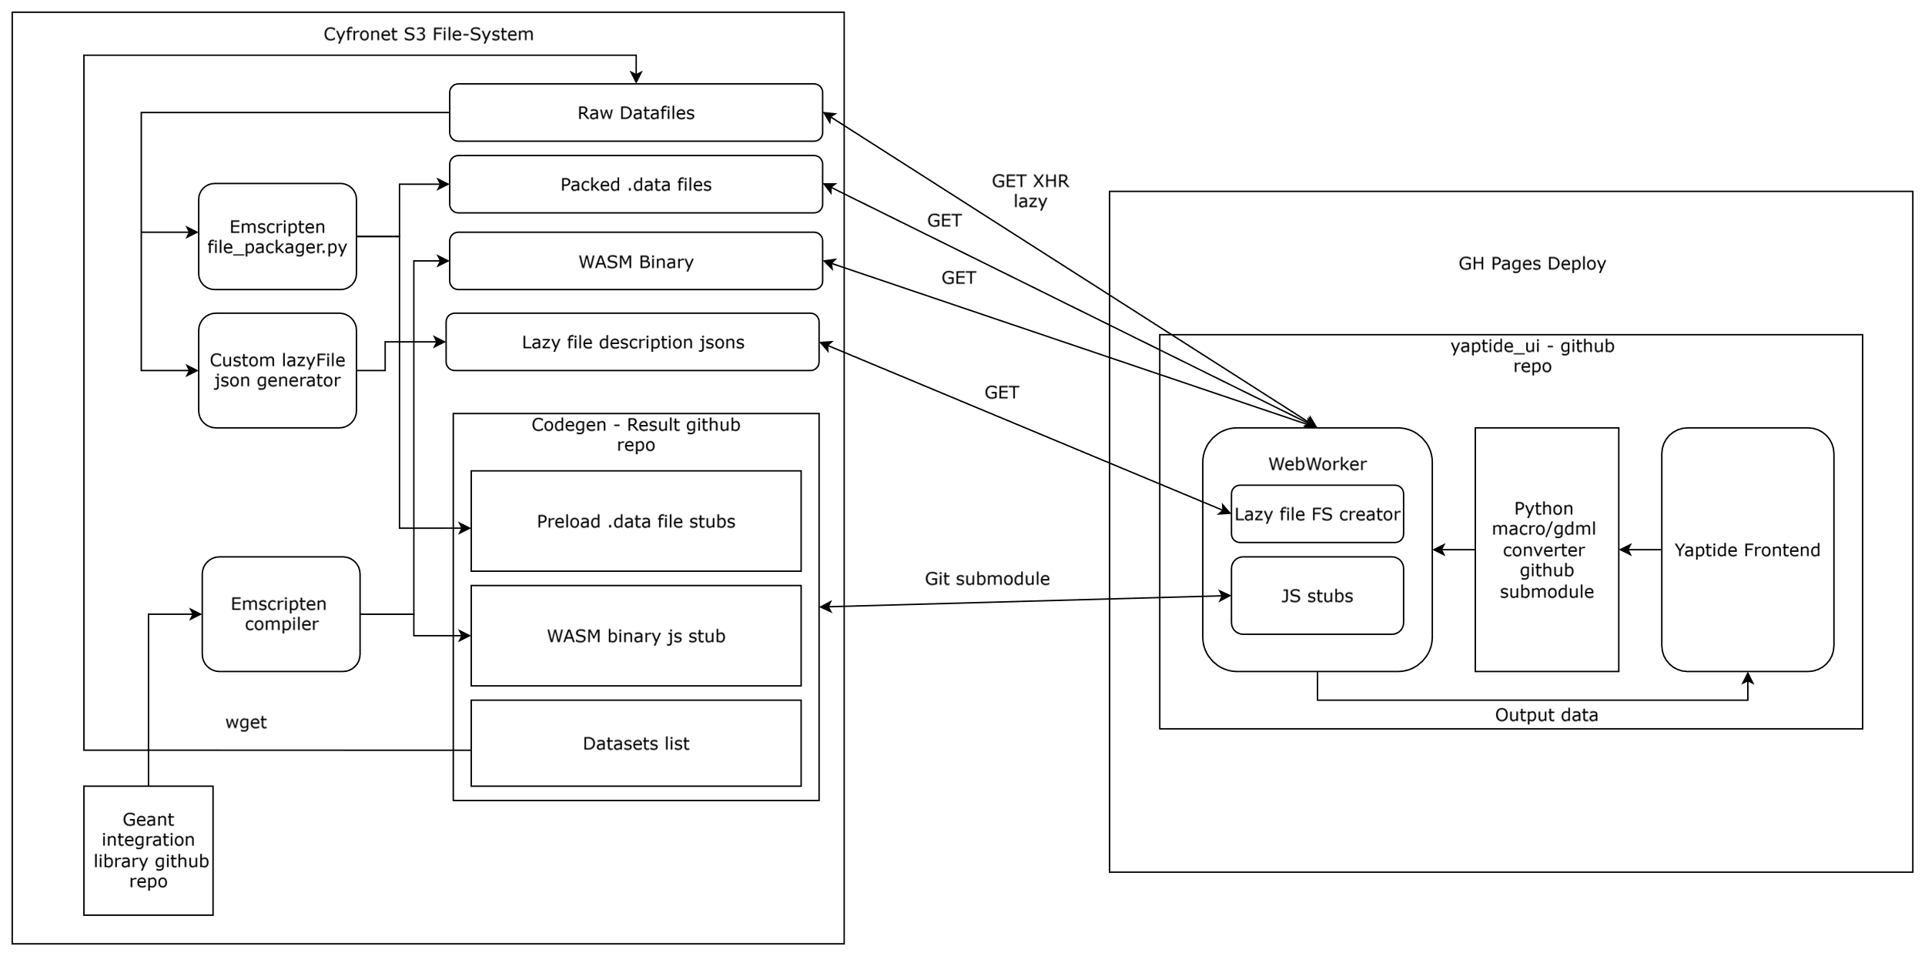

**Fig.1.** Architecture of the demonstrator application.

1. Conclusions and future work

This on-device, browser-based radiotherapy simulation framework merges the accessibility and ease of web applications with the security and privacy benefits of client-side computation. It addresses substantial practical and regulatory challenges by eliminating the need to upload sensitive health data for particle transport simulations.

Future research will focus on further optimizing performance using GPU acceleration APIs like WebGPU, expanding support for more complex simulation scenarios, and enhancing the user interface with real-time collaborative features.

Acknowledgements. We gratefully acknowledge Polish high-performance computing infrastructure PLGrid (HPC Center: ACK Cyfronet AGH) for providing computer facilities and support within computational grant no. PLG/2024/017746. We acknowledge the contributions of Yaptide platform developers: Szymon Ciosek, Jakub Niechaj, and Szymon Kania.

References

1. Basaglia, Tullio, et al. "Geant4: A game changer in high energy physics and related applicative fields." Future Generation Computer Systems 159 (2024): 411-422.
2. Ziegler, Erik, et al. "Open health imaging foundation viewer: an extensible open-source framework for building web-based imaging applications to support cancer research." JCO clinical cancer informatics 4 (2020): 336-345.