**Comparison of MRI-derived Cardiac Power with and without Deep Learning Acceleration**

Grace Faulkner1,2, Paul Morris1,2,3, Ian Halliday1,2

1Division of Clinical Medicine, School of Medicine and Population Health, University of Sheffield, Sheffield S10 2TN, UK  
2INSIGNEO Institute for in silico Medicine, Sheffield S1 3JD, UK

3Department of Cardiology, Sheffield Teaching Hospitals NHS Foundation Trust, Sheffield S10 2JF, UK  
*gfaulkner1@sheffield.ac.uk***Keywords**: MRI, deep learning, cardiac power, cardiovascular

1. **Introduction**

Cardiac power at rest and in exercise can provide useful diagnostic information across a range of cardiovascular pathologies. Historically, this informative metric could only be quantified invasively, limiting its clinical use. However, a recent method derives cardiac power non-invasively using volumes derived from cardiac MRI (CMR) [1]. This method has been tested and validated at rest [2], but further work is needed to develop this method for use during exercise.

1. **Description of the problem**

Data acquisition during exercise is complex; motion within the MRI scanner can cause artefact in the acquisitions, leading to low-quality or unusable results. Exercise within the bore of the scanner is possible using a compatible supine cycle ergometer, but testing by this group has revealed the acquisition is still affected by artefact. Furthermore, it has been shown in the literature that acquisition longer than four seconds after the cessation of exercise causes significantly different end-systolic and end-diastolic volumes (ESV and EDV, respectively) [3]. To overcome this, the acquisition process can be accelerated using deep learning software which under-samples the k-space to reduce the scan time. The uncertainty in the volumes and cardiac power calculated using this accelerated method remains to be quantified. In this work we will compare the cardiac power at rest for one participant as a case study, both with and without a commercial deep learning algorithm to quantify the inherent uncertainty of the deep learning acceleration of left-ventricular power.

1. **Related work**

The foundation for the non-invasive cardiac power quantification is by Seemann et al. who use a 0D elastance model to relate the volume to the pressure in the chamber [1]. This method was optimised by previous work in this group to validate the choice of elastance model used [4].

1. **Solution to the problem**

A single participant (28 year old male) was used as a test case. CMR was performed on a 1.5-Tesla Siemens Signa Artist system (Siemens Healthineers AG, Erlangen, Germany) and analysed using Research software, MASS, (Geest, Leiden). Brachial systolic and diastolic pressure were also collected using a sphygmomanometer. Short-axis stacks were taken at rest, once with the deep learning acceleration, sonic DL (Siemens Healthineers AG, Erlangen, Germany), and once without. All other parameters were unchanged. The corresponding pressure was recovered using a double cosine elastance as previously described [4]. The cardiac power was derived from the area of a plot of the pressure-volume loop. See Fig 1.

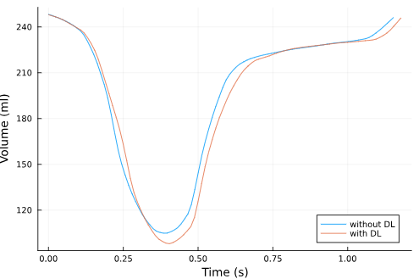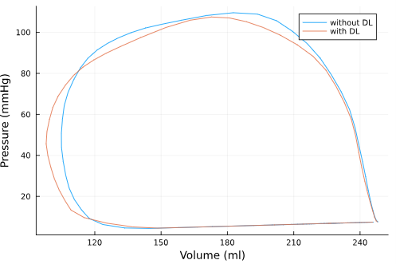

**Fig.1. (Left)** time-series volume **(Right)** pressure-volume loops for the case study participant. Blue traces denote data derived without sonic DL, red denote the results when deep learning acceleration was used.

HR and cuff pressure were similar during both acquisitions, indicating the participant was in the same physiological state. The difference between HRs in both acquisitions was 1.1 bpm (2.1%) and the difference in the estimated end-systolic pressure was 2.1 mmHg (1.9%) for this participant.

Volumes were also closely aligned between the two methods. The difference in ESV was greater than the difference in end-diastolic volume but still within acceptable limits (ESV, 6.8 ml (6.5%); EDV, 0.2 ml (0.1%)). The resulting cardiac power was therefore similar between the two volume acquisitions, with a difference of 0.01J (0.64%).

1. **Conclusions and future work**

This case study suggests that using deep learning acceleration has little impact on the accuracy of the acquisition. These results are limited, as they were tested for one healthy volunteer at rest, but are promising for future testing of patients and in the exercise state, where the length of acquisition would be obstructive without deep learning acceleration.

**Acknowledgements.** This work was carried out at the National Institute for Health and Care Research Sheffield Biomedical Research Centre, and supported by Sheffield Teaching Hospitals.

**References**

1. Seemann F, Arvidsson P, Nordlund D, Kopic S, Carlsson M, Arheden H, et al. Noninvasive quantification of pressure-volume loops from brachial pressure and cardiovascular magnetic resonance. Circ Cardiovasc Imaging. 2019 Dec; 12(1):e008493
2. Arvidsson PM, Green PG, Watson WD, Shanmuganathan M, Heiberg E, Maria GLD, et al. Non-invasive left ventricular pressure-volume loops from cardiovascular magnetic resonance imaging and brachial blood pressure: validation using pressure catheter measurements. Eur Heart J Imaging Methods Pract. 2023 Oct 25;1(2):1-10
3. Beaudry, R. I., Samuel, T. J., Wang, J., Tucker, W. J., Haykowsky, M. J., & Nelson, M. D. Exercise cardiac magnetic resonance imaging: a feasibility study and meta-analysis. Am J Physiol Regul Integr Comp Physiol. 2018 June 20; 315:638–645.
4. Faulkner, G., Matthews, G., Halliday, I., Saxton, H., Taylor, D.J., Newman, T. et al. (submitted June 2025). The Role of Elastance Models in Non-Invasive Left Ventricular Pressure-Volume Loop Construction. EHJ-DH.