**Portable Auscultation Device for Perfusion Evaluation - 5PAudio, a novel personalized Monitoring and Prediction approach**

Michael Friebe1, Katarzyna Heryan1, Hamza Oran1, Dominik Rzepka1

1AGH University of Krakow, Faculty of Computer Science, Healthtech Innovation Group, 30-059 Kraków, Poland{*friebe, heryan, oran, rzepka*}@*agh.edu.pl***Keywords**: Acoustic Sensing, Perfusion Monitoring, Stroke Prediction, Acoustic Body Atlas

1. Introduction

Stroke imposes substantial health and economic burdens worldwide, yet timely identification of high-risk individuals remains challenging. Imaging-based screening, such as Doppler ultrasound, is resource intensive and unsuitable for frequent or widespread use [1–3]. Recent advances in biomedical acoustics show that vascular sound patterns can reveal early disease indicators. 5PAudio—a handheld device generating an individualized vascular audio biomarker (Fig. 1). Its portability and affordability make it suitable for routine and home-based monitoring, addressing a critical gap in preventive healthcare.

1. Description of the problem

Carotid artery stenosis is a major cause of ischemic stroke, often progressing silently. Current diagnostic imaging requires specialized equipment and expertise, limiting accessibility. Post-stenting restenosis monitoring shares these limitations. An accessible, repeatable tool for early detection and follow-up could enable timely interventions, particularly in underserved populations.

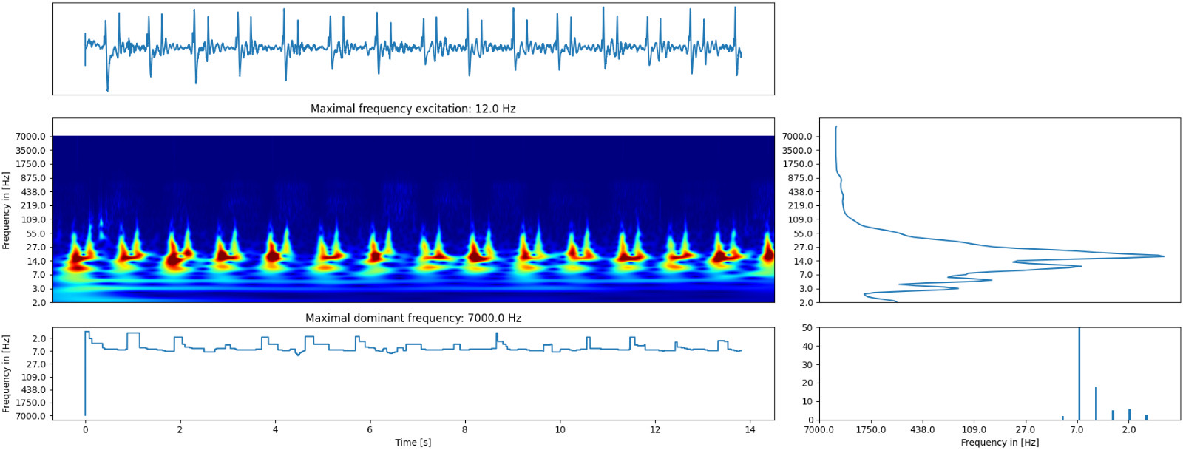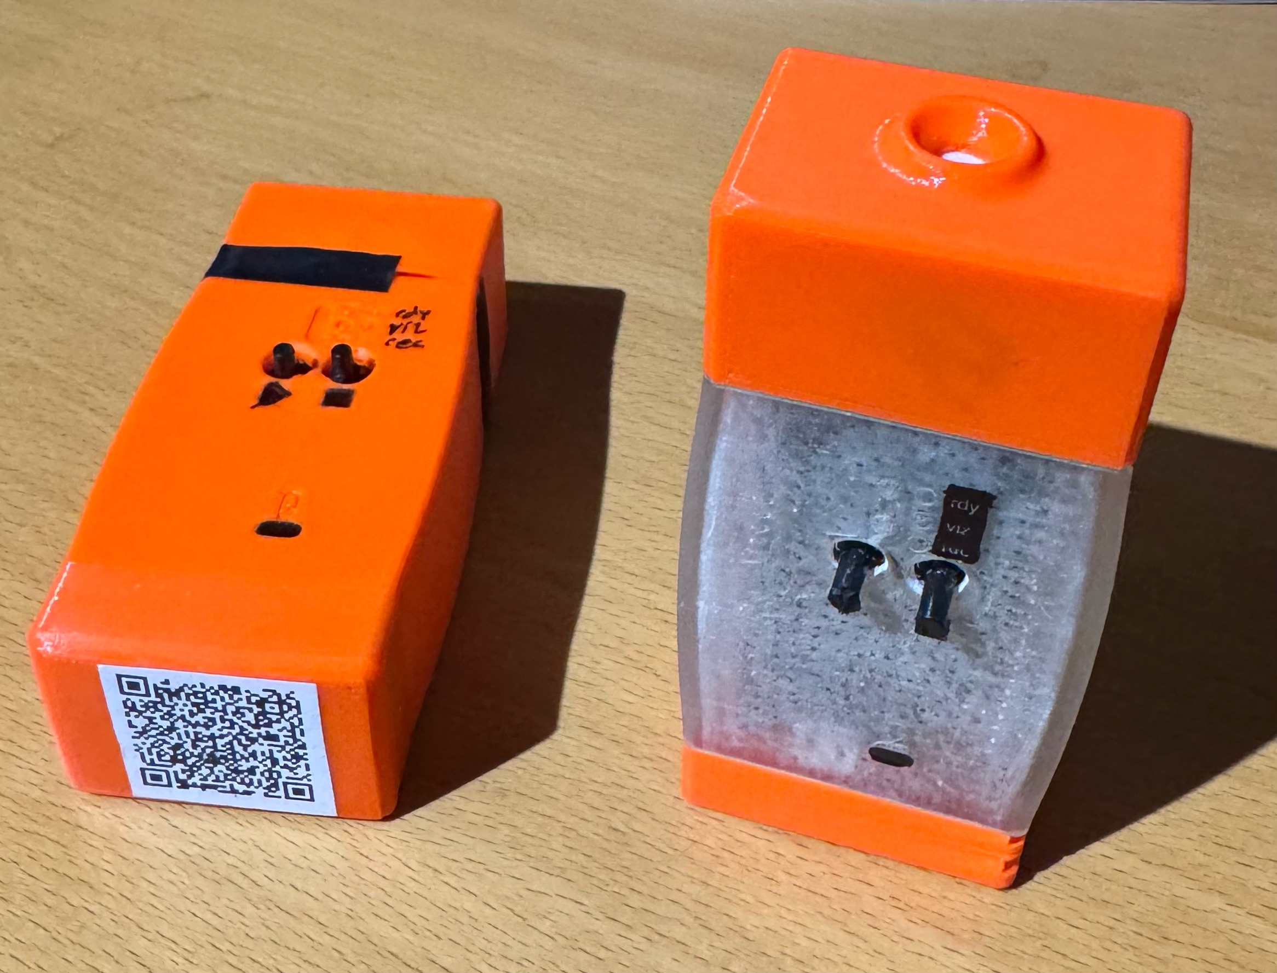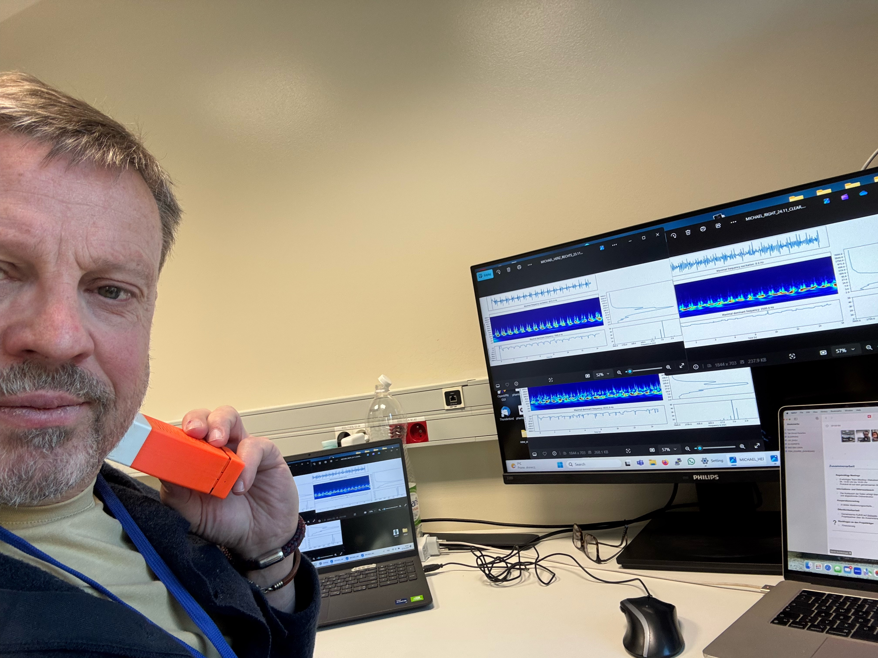

*Fig. 1: The prototype devices on the top left. The acquisition screen shows the frequency spectrum of the individual. Every individual has a unique frequency profile that can be used as an audio biomarker as part of a digital health twin.*

1. Related work

Vascular auscultation has been examined for disease detection, with studies showing that carotid blood flow sounds are stable and unique. Phonocardiography for heart disorders and respiratory audio analysis for lung disease demonstrate the broader diagnostic value of biomedical sound analysis. Yet, no established portable system exists for vascular audio biomarker-based stroke prevention [3,4].

1. Solution to the problem

5PAudio uses a handheld vibroacoustic sensor (see Figure 1) to capture carotid blood flow sounds. Advanced algorithms segment the signal and extract features indicating turbulent or restricted flow. The resulting personalized biomarker can be applied to:

1. Early screening for asymptomatic stenosis,
2. Progression tracking in diagnosed cases,
3. Restenosis detection after stenting.

Our Audio4Prevention extension aims to combine vascular, respiratory, and joint sound biomarkers for multi-organ health monitoring in the future [4-6].

5. **Conclusions and future work**

A vascular audio biomarker device offers a scalable, non-invasive means of preventing stroke and supporting long-term health monitoring. Future goals include refining analysis algorithms, expanding biomarker libraries, and validating effectiveness through large-scale clinical trials, with integration into telemedicine systems for broad access [7-9].

Acknowledgements and Conflict of Interest. The authors declares no conflict of interest. This work was supported by the National Science Centre (NCN), Poland (Grant No. 2021/43/I/ST7/03098), and the Deutsche Forschungsgemeinschaft (DFG), Germany (Grant No. 504923173), under the OPUS-22 LAP framework. Additional support was provided by the "Excellence Initiative – Research University" program at AGH University of Krakow.

References

1. Feigin, V. L., et al. Global burden of stroke and risk factors in 195 countries and territories, 1990–2019. Lancet Neurol., 2022; 21(10): 877–897.
2. World Health Organization. Stroke – Key facts. WHO Health Topics, 2023.
3. Grant, E. G., et al. Carotid artery stenosis: Gray-scale and Doppler US diagnosis—Society of Radiologists in Ultrasound Consensus. Radiology, 2017; 282(2): 354–369.
4. Salvi, R., et al. Vascular Auscultation of Carotid Artery: Towards Biometric Identification and Verification of Individuals. Sensors, 2021; 21: 19656. <https://doi.org/10.3390/s21196656>
5. Sühn T, et al (2020). Auscultation System for Acquisition of Vascular Sounds – Towards Sound-Based Monitoring of the Carotid Artery. Med Devices. doi: 10.2147/MDER.S268057
6. Schaufler A, et al (2021). Sensor-based measurement for advanced monitoring and early detection of PE wear in total knee arthroplasties. Current Directions in Biomedical Engineering. [doi: 10.1515/cdbme-2021-2072](https://doi.org/10.1515/cdbme-2021-2072)
7. Patent application DE 10 2020 114 070 + DE 10 2023 001285
8. Kumar, D., et al. Phonocardiographic signal analysis for diagnosis of heart valve disorders. IEEE Rev. Biomed. Eng., 2018; 11: 187–203.
9. André, S., et al. From lung sounds to diagnosis: A narrative review. Comput. Biol. Med., 2018; 103: 135–144.