**Digital Twin-Based Prognostic Modeling in Aortic Coarctation and Hypoplastic Aortic Arch**

Krystian Jędrzejczak1,*, Rawan Abuzinadah2, Paola Franceschi3, 4, Julio Sotelo5, Malenka M. Bissell2, Łukasz Makowski1

1 Warsaw University of Technology, Faculty of Chemical and Process Engineering, Waryńskiego 1, Warsaw, Poland

2 University of Leeds, Leeds Institute of Cardiovascular and Metabolic Medicine, Leeds, UK

3 Pediatric and Adult CardioThoracic and Vascular, Oncohematologic and Emergency Radiology Unit, IRCCS University Hospital of Bologna, Via Massarenti 9, 40138, Bologna, BO, Italy

4 Department of Surgical and Medical Sciences (DIMEC), University of Bologna, Bologna, Italy

5 Departamento de Informática, Universidad Técnica Federico Santa María, Santiago, Chile

* Corresponding author: e-mail: krystian.jedrzejczak@pw.edu.pl  
**Keywords**: CFD, congenital heart defects, personalized medicine, digital twin, ResNet

1. Introduction

Congenital heart defects are identified in around 1% of newborns [1]. In particular, defects such as aortic coarctation and hypoplastic aortic arch can cause symptoms in neonates such as poor feeding tolerance, respiratory distress, cold extremities, diminished or absent femoral pulses, pallor, and tachycardia.

1. Description of the problem

Current procedures for identifying congenital cardiovascular defects rely primarily on fetal echocardiography (ECHO) during pregnancy [2]. However, the limited resolution of this imaging technique, combined with the growing prevalence of maternal obesity, makes it particularly challenging to diagnose conditions such as aortic coarctation and hypoplastic aortic arch. As an alternative, other imaging methods such as magnetic resonance imaging (MRI) may be considered, although MRI is not yet a standard procedure during pregnancy or in newborns [3], [4]. Moreover, in the case of small vessels, MRI may not provide sufficient image quality. Therefore, it is necessary to use artificial intelligence techniques to upscale and enhance the quality of medical images.

1. Related work

The use of magnetic resonance imaging combined with artificial intelligence for the development of new diagnostic methods is an active area of research at the intersection of medicine and engineering [3], [4], [5]. This topic strongly resonates within the scientific literature, reflecting growing interest in interdisciplinary approaches to improving diagnostic accuracy and patient outcomes.

1. Solution to the problem

As part of the study, 4D Flow MRI examinations were conducted on newborns after obtaining approvals from the bioethics committee and informed consent from the children's legal guardians. The acquired 4D Flow MRI data were subsequently upscaled using a neural network to improve spatial resolution and enhance the signal-to-noise ratio [5], [6]. These data were used to develop both a generalized numerical model of aortic coarctation and personalized models, which served to identify key parameters enabling the diagnosis of these congenital cardiovascular defects. The results of the CFD analyses were compared with data obtained from the 4D Flow MRI using the 4D Flow MRI Toolbox for MATLAB [7] and the Cass software.

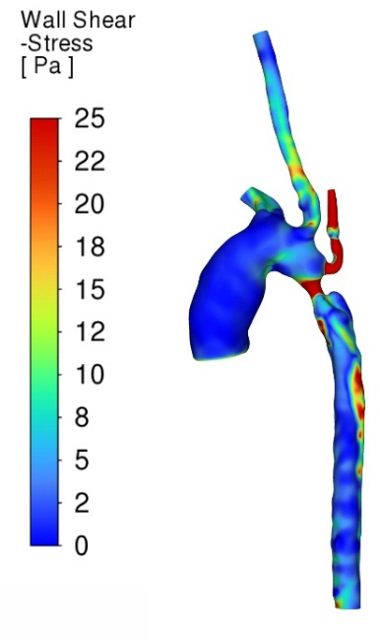

**Fig.1.** Wall shear stress [Pa] distribution contours for an newborn with aortic coarctation.

1. Conclusions and future work

Our research enabled the identification of key parameters essential for the accurate diagnosis of aortic coarctation and hypoplastic aortic arch in infants, based on 4D Flow MRI data enhanced by artificial neural networks and supported by CFD simulations.

Acknowledgements. Research was funded by Warsaw University of Technology within the Excellence Initiative: Research University (IDUB) programme.

References

1. C. Mamasoula et al., “Prevalence of congenital heart defects in Europe, 2008–2015: A registry-based study,” Birth Defects Res., vol. 114, no. 20, pp. 1404–1416, 2022, doi: 10.1002/bdr2.2117.
2. G. Tuo et al., “Fetal aortic coarctation: A combination of third-trimester echocardiographic parameters to improve the prediction of postnatal outcome.,” Front. Pediatr., vol. 10, p. 866994, 2022, doi: 10.3389/fped.2022.866994.
3. P. Dyverfeldt et al., “4D flow cardiovascular magnetic resonance consensus statement,” J. Cardiovasc. Magn. Reson., vol. 17, no. 1, p. 72, 2015, doi: 10.1186/S12968-015-0174-5.
4. M. M. Bissell et al., “4D Flow cardiovascular magnetic resonance consensus statement: 2023 update,” J. Cardiovasc. Magn. Reson., vol. 25, no. 1, p. 40, 2023.
5. E. Ferdian et al., “4DFlowNet: Super-Resolution 4D Flow MRI Using Deep Learning and Computational Fluid Dynamics,” Front. Phys., vol. 8:138, 2020, doi: 10.3389/fphy.2020.00138.
6. E. Ferdian et al., “Cerebrovascular super-resolution 4D Flow MRI – Sequential combination of resolution enhancement by deep learning and physics-informed image processing to non-invasively quantify intracranial velocity, flow, and relative pressure,” Med. Image Anal., vol. 88, p. 102831, 2023, doi: 10.1016/J.MEDIA.2023.102831.
7. J. Sotelo, J. Mura, D. Hurtado, and S. Uribe, “A novel MATLAB toolbox for processing 4D Flow MRI data,” Int. Soc. Magn. Reso-nance Med., 2019.