**Interpretable Machine Learning for Glioma Grading from HLA-DR–Stained Whole-Slide Images: Multi-Feature Analysis with SHAP**

Monika Pytlarz¹, Yevgheni Petkevich¹, Kamil Wojnicki2, Beata Kaza3, Wiesława Grajkowska4, Łukasz Michałowski5, Bożena Kamińska3, Jan Argasiński¹

1Sano Centre for Computational Medicine, Czarnowiejska 36, 30-054 Kraków, Poland

2University Children’s Hospital Zurich, Lenggstrasse 30, 8008 Zürich, Switzerland

3Nencki Institute of Experimental Biology, 3 Pasteur Street, 02-093 Warszawa, Poland

4Department of Pathology, The Children’s Memorial Health Institute, Av. Dzieci Polskich 20, 04-730 Warsaw Poland

5Department of Pathology, University Clinical Centre of the Medical University of Warsaw, Jana Nielubowicza 5, 02-097 Warszawa, Poland  
{m.pytlarz, y.petkevich, [j.argasinski}@*sanoscience.org*](mailto:j.argasinski%7d@sanoscience.org)*,* [*kamil.wojnicki@kispi.uzh.ch*](mailto:kamil.wojnicki@kispi.uzh.ch)*, {*[*b.kaza, b.kaminska}@nencki.edu.pl*](mailto:b.kaza@nencki.edu.pl)*,* [*W.Grajkowska@ipczd.pl*](mailto:W.Grajkowska@ipczd.pl)*,* [*michalowski.patologia@gmail.com*](mailto:michalowski.patologia@gmail.com)**Keywords**: glioma; interpretable classification, microglia/macrophages; HLA‑DR/DP/DQ; digital pathology; amoeboid vs ramified; Cellpose, image complexity; radiomics

1. Introduction

Gliomas show heterogeneous histomorphology and immune infiltration that correlate with tumor grade. Microglia/macrophages, identified by HLA-DR, adopt morphologies ranging from ramified to amoeboid, reflecting activation states. Manual assessment of whole slide images (WSIs) is laborious and subjective, creating a need for automated and interpretable grading approaches.

1. Description of the problem

Computational histopathology of glioma WSIs faces biological heterogeneity, technical variability, and the requirement of model transparency. As AI for medical imaging moves beyond opaque black-box models [1,2], reproducible approaches linking predictions to underlying biology are required to support clinical adoption.

1. Related work

Activated microglia/macrophages shift from ramified to amoeboid morphology and are more common in higher grades [3–5]. Beyond cell features, image-complexity measures can reflect tumor heterogeneity and may relate to IDH mutation status [6]. Recent studies reflect a growing interest in explainable approaches to glioblastoma assessment [2], yet immune-related features have been less frequently investigated in computational histopathology, despite evidence of their prognostic relevance.

1. Solution to the problem

We developed an interpretable ML pipeline for HLA-DR–stained WSIs (WHO G1–G4) with robust preprocessing, integrating immune morphology, image complexity, and deep features. Interpretability was ensured through SHAP, linking predictions to underlying biology. The dataset comprised 110 HLA-DR/DP/DQ–stained glioma WSIs, tiled into 1024×1024 px patches with 10% overlap, with background removed using conservative HSV-based subtraction. Nuclei were segmented with a pretrained Cellpose [7] model; HLA-DR-positive cytoplasmic/membranous signal was segmented using HSV thresholding and assigned to nuclei via watershed, yielding cell-level morphology descriptors. We then extracted 4 feature categories (Fig. 1): (1) morphology (ramified vs amoeboid phenotypes), (2) image complexity (e.g., entropy, fractal dimension, lacunarity), (3) radiomics (first- and second-order), and (4) deep embeddings (ResNet-50). Preliminary classification used XGBoost with SHAP. Entropy rose prominently from G2 to G4, with G4 showing the highest values and greatest variability, indicative of increased heterogeneity. The amoeboid fraction rose with grade. XGBoost reached 0.93. SHAP ranked entropy as the top feature, with ResNet-50 embeddings, first-order radiomics, and amoeboid count also in the top five.

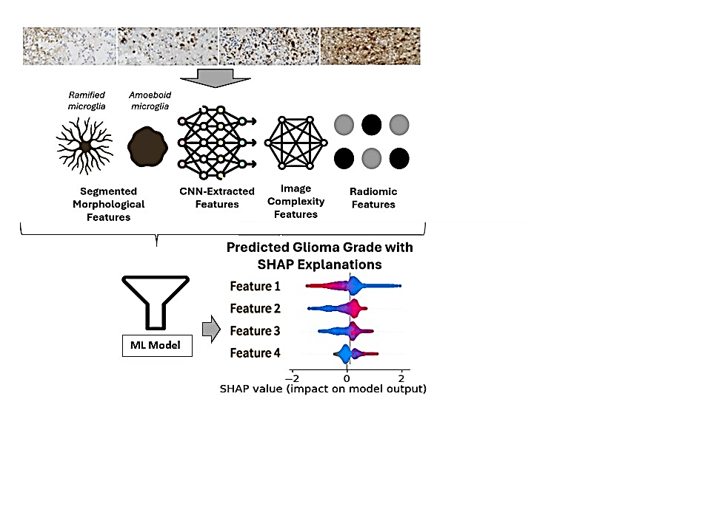

**Fig.1.** Pipeline design.

1. Conclusions and future work

Our analysis captures immune, morphological, and complexity characteristics of the gliomas across grades. Combining handcrafted and deep features in the ML classification with SHAP enhances biological relevance. Next steps include testing ensemble classifiers, refining preprocessing, and evaluating links between low-complexity histology and IDH mutation.

**Acknowledgements.** Supported by EU Horizon 2020 (857533), Foundation for Polish Science (MAB PLUS/2019/13), Polish Ministry of Science (MEiN/2023/DIR/3796), and PLGrid infrastructure (PLG/2025/018289).

References

1. Van der Velden B.H., et al., 2022. Explainable artificial intelligence (XAI) in deep learning-based medical image analysis. Medical image analysis, 79, p.102470.
2. Baheti, B., et al., 2025. Multimodal explainable artificial intelligence for prognostic stratification of patients with glioblastoma. Modern Pathology, 38(9), p.100797.
3. Dugandžija, T., et al., 2021. Hallmarks of tumor-associated microglia response to experimental U87 human glioblastoma xenograft. Tissue and Cell, 72, p.101557.
4. Kvisten, M., et al., 2019. Microglia and macrophages in human glioblastomas: A morphological and immunohistochemical study. Molecular and clinical oncology, 11(1), pp.31-36.
5. Constanzo, J., et al., 2020. Brain irradiation leads to persistent neuroinflammation and long-term neurocognitive dysfunction in a region-specific manner. Prog Neuropsychopharmacol, 102, 109954.
6. Yadav, N., et al., 2024. Fractal dimension and lacunarity measures of glioma subcomponents are discriminative of the grade of gliomas and IDH status. NMR in Biomedicine, 37(12), p.e5272.
7. Stringer, C. et al., 2021. Cellpose: a generalist algorithm for cellular segmentation. Nature methods, 18(1), 100-106.