Sharp-to-Soft CT Kernel Conversion Using Quaternion and Variational Decomposition Mode
Mahmoud Nasr^{1,2}, Krzysztof Brzostowski³, and Adam Piórkowski²
¹Sano Centre for Computational Medicine, Czarnowiejska 36, 30-054 Kraków, Poland
²Department of Biocybernetics and Biomedical Engineering, AGH University of Krakow, Poland.
³Wroclaw University of Science and Technology, Faculty of Information and Communication Technology, Wroclaw, Poland.
Keywords: CT, Kernel Conversion, Quaternion, Bilateral Filter, VMD, Image Denoising.
- Introduction
Computed tomography (CT) imaging is fundamental to contemporary diagnostic radiology, and image quality is significantly affected by the reconstruction kernel. Sharp kernels improve edge clarity but generate considerable noise, whereas soft kernels diminish noise at the expense of obscuring small features. Transforming images from sharp to soft kernels is crucial for uniform image analysis and subsequent tasks such as segmentation or radiomics, eliminating the need for further scans. Recent studies have investigated deep learning and filtering-based methodologies to tackle this difficulty [1, 2].
- Description of the problem
The main difficulty is to reduce the noise in sharp-kernel CT images while maintaining structural information to align with soft-kernel reconstructions. Conventional filters may blur edges or inadequately attenuate noise. Deep learning methodologies yield superior conversion quality, but need significant computer resources and extensive training datasets, restricting their practical application in clinical environments. An effective method for converting sharp kernel images to soft-like images, without significant data requirements or feature loss, is greatly sought after.
- Related work
The Previous studies have investigated both model-based and learning-based methodologies for CT kernel conversion and denoising. Deep convolutional networks have shown proficiency in transforming sharp- kernel images into soft-kernel counterparts while preserving structural details. However, they require considerable training data [1]. Based filtering methods provide an alternative by simulating the point spread function of the scanner to facilitate kernel conversion [3]. Sparse representation methods have been suggested for CT denoising, efficiently diminishing noise while maintaining image structures. Although effective, these methods require extensive datasets or prior knowledge of the system parameters, underscoring the need for a practical and efficient solution.
- Solution to the problem
We offer an innovative kernel conversion framework that amalgamates bilateral quaternion filtering (QBF) [4] with decomposition methodologies, such as Variational Mode Decomposition (VMD) [5]. Our method in Fig. 1 utilizes a quaternion representation of CT images to process multichannel information, maintaining interchannel correlations concurrently. QBF efficiently diminishes noise and sharpens edges, generating soft-kernel images from sharp-kernel inputs. Compared to deep learning techniques, our methodology requires limited data and processing duration, which makes it highly appropriate for therapeutic applications.

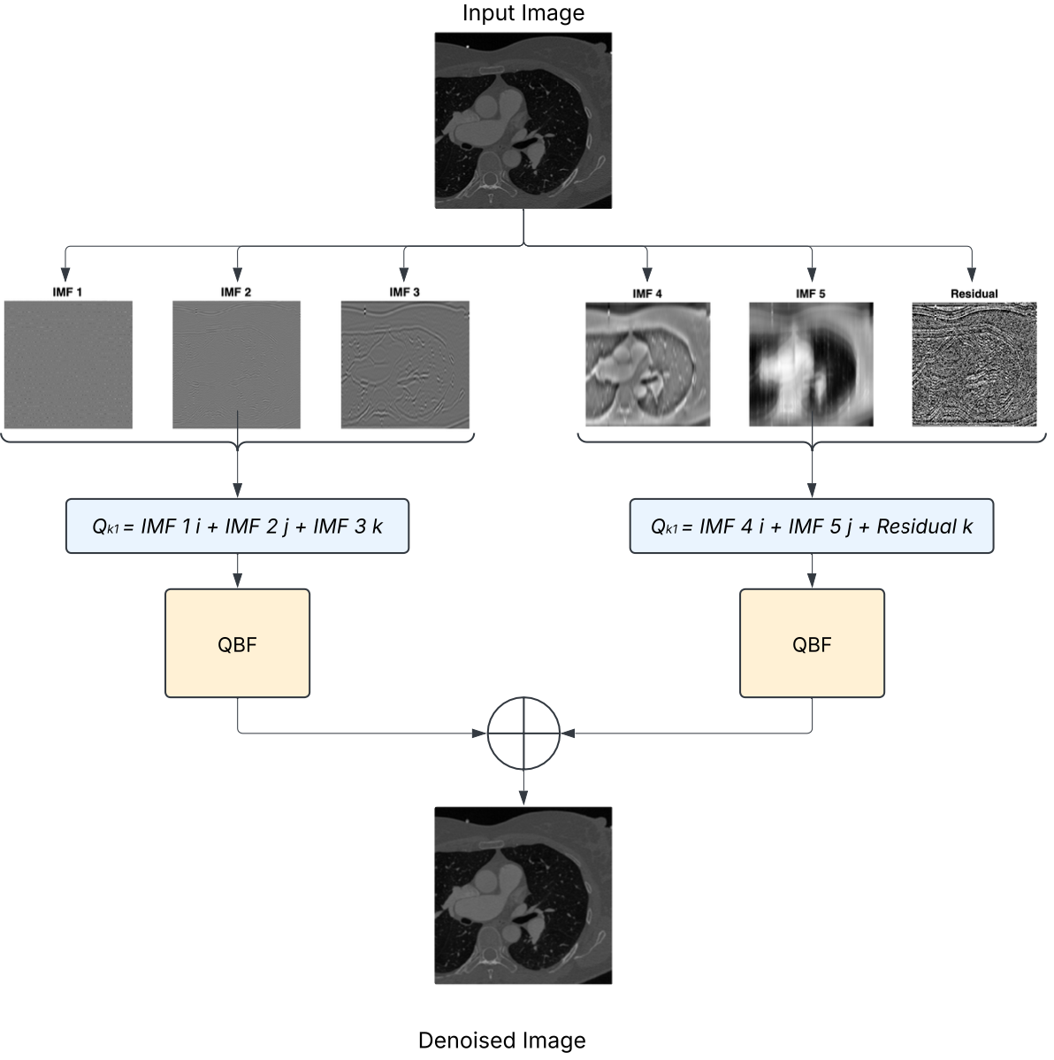

Fig.1. The Proposed Method for representing the VMD IMFs to Quaternion form and Applying the QBF.

- Conclusions and future work
The suggested quaternion-based technique offers a practical and pragmatic solution for CT kernel conversion, producing soft-kernel-like images from sharp-kernel inputs while maintaining structural integrity and minimizing noise. This paradigm diminishes reliance on extensive training datasets and expedites processing time relative to deep learning techniques. Subsequent efforts will concentrate on incorporating this methodology into automated segmentation processes and assessing its generalizability across multi-center datasets.
Acknowledgements. This project has received funding from the European Union's Horizon 2020 research and innovation programme under grant agreement No 857533 and from the International Research Agendas Programme of the Foundation for Polish Science No MAB PLUS/2019/13.
References
- C. Choi, D. Kim, S. Park, H. Lee, H. Kim, S. M. Lee, and N. Kim, “Kc-unit: Multi-kernel conversion using unpaired image-to-image translation with perceptual guidance in chest computed tomography imaging,” Computers in Biology and Medicine, vol. 196, p. 110846, 2025.
- S. Yang, E. Y. Kim, and J. C. Ye, “Continuous conversion of ct kernel using switchable cyclegan with adain,” IEEE transactions on medical imaging, vol. 40, no. 11, pp. 3015–3029, 2021.
- J. Lasek and A. Pi´orkowski, “Ct scan transformation from a sharp to a soft reconstruction kernel using filtering techniques,” in International Conference on Computer Vision and Image Processing. Springer, 2020, pp. 56–65.
- M. Nasr, A. Pi´orkowski, K. Brzostowski, and F. E. Abd El-Samie, “A novel approach for ct image smoothing: Quaternion bilateral filtering for kernel conversion,” Computers in Biology and Medicine, vol. 196, p. 110644, 2025.
- K. Dragomiretskiy and D. Zosso, “Variational mode decomposition,” IEEE transactions on signal processing, vol. 62, no. 3, pp. 531–544, 2013.

