**Aggregating gut: on the link between neurodegeneration and bacterial functional amyloids**

Alicja W. Wojciechowska1,2, Jakub W. Wojciechowski1, Kinga Zielinska3, Johannes Soeding4,   
Tomasz Kosciolek1, Malgorzata Kotulska2

1Sano Centre for Computational Medicine, Czarnowiejska 36, 30-054 Kraków, Poland  
2Wroclaw University of Science and Technology, Faculty of Fundamental Problems of Technology, Department of Biomedical Engineering, Wroclaw, Poland

3Malopolska Centre of Biotechnology, Jagiellonian University, Krakow, Poland

4Max Planck Institute for Multidisciplinary Sciences, Gottingen, Germany

{*a.wojeciechowska, j.wojciechowski, t.kosciolek*}@*sanoscience.org*, {*kinga.zielinska*}*@*[*uj.edu.pl*](http://uj.edu.pl)*, {soeding}@*[*mpinat.mpg.de*](http://mpinat.mpg.de)*, {malgorzata.kotulska}@pwr.edu.pl*  
  
**Keywords**: microbiome, neurodegeneration, protein

1. **Introduction**

The human gut microbiome is known to influence human health by providing essential substances and modulating immune responses. The onset and progression of neurodegenerative diseases are dependent on these processes, though the details of the gut-brain crosstalk in these disorders remain elusive. Recent studies reveal that gut bacteria produce bacterial functional amyloids, proteins with structures similar to the misfolded human proteins linked to neurodegenerative diseases [1]. This structural similarity allows them to potentially trigger or accelerate the aggregation of human proteins, such as alpha-synuclein, a key protein in Parkinson's disease [2]. This process may originate in the gut and spread to the brain via the vagus nerve, suggesting that the disease could start in the gut [2, 3]. Further research is necessary to fully understand the role of these bacterial amyloids, which could lead to new diagnostic and therapeutic strategies for neurodegenerative diseases.

1. **Description of the problem**

To fully understand the role of bacterial functional amyloids in neurodegeneration, we must investigate three key areas. First, we are interested in estimating how many such proteins are produced by the human gut microbiome. Second, we want to evaluate whether the abundance of such proteins is associated with the disease. Finally, we aim to identify human molecular pathways which could be affected by bacterial functional amyloids.

1. **Related work**

Wang et al. [4] have shown that E. coli bacterial amyloid CsgA promotes neuropathologies by inducing the aggregation of pathological amyloids, colocalizing with them in the neurons and downregulating the mitochondrial genes in C. elegans. Intestinal Bap amyloids produced by Staphylococcus have been found to promote neurodegeneration in mice and proposed as future biomarkers of such pathologies [5].

1. **Solution to the problem**

Using a bioinformatics approach, we identify gut microbiome functional amyloids and analyze their potential impact on human health via the gut-brain axis. The results point to taxonomically diverse sources of functional amyloids (Fig. 1) and their frequent presence in the extracellular space. The retrieved interactions between gut microbiome functional amyloids and human proteins indicate their potential to trigger inflammation, affect transport and signalling processes. We also find a greater relative abundance of bacterial functional amyloids in patients diagnosed with Parkinson’s disease and specifically a higher content of the curli amyloid protein, CsgA, in Alzheimer’s disease patients than in healthy controls.

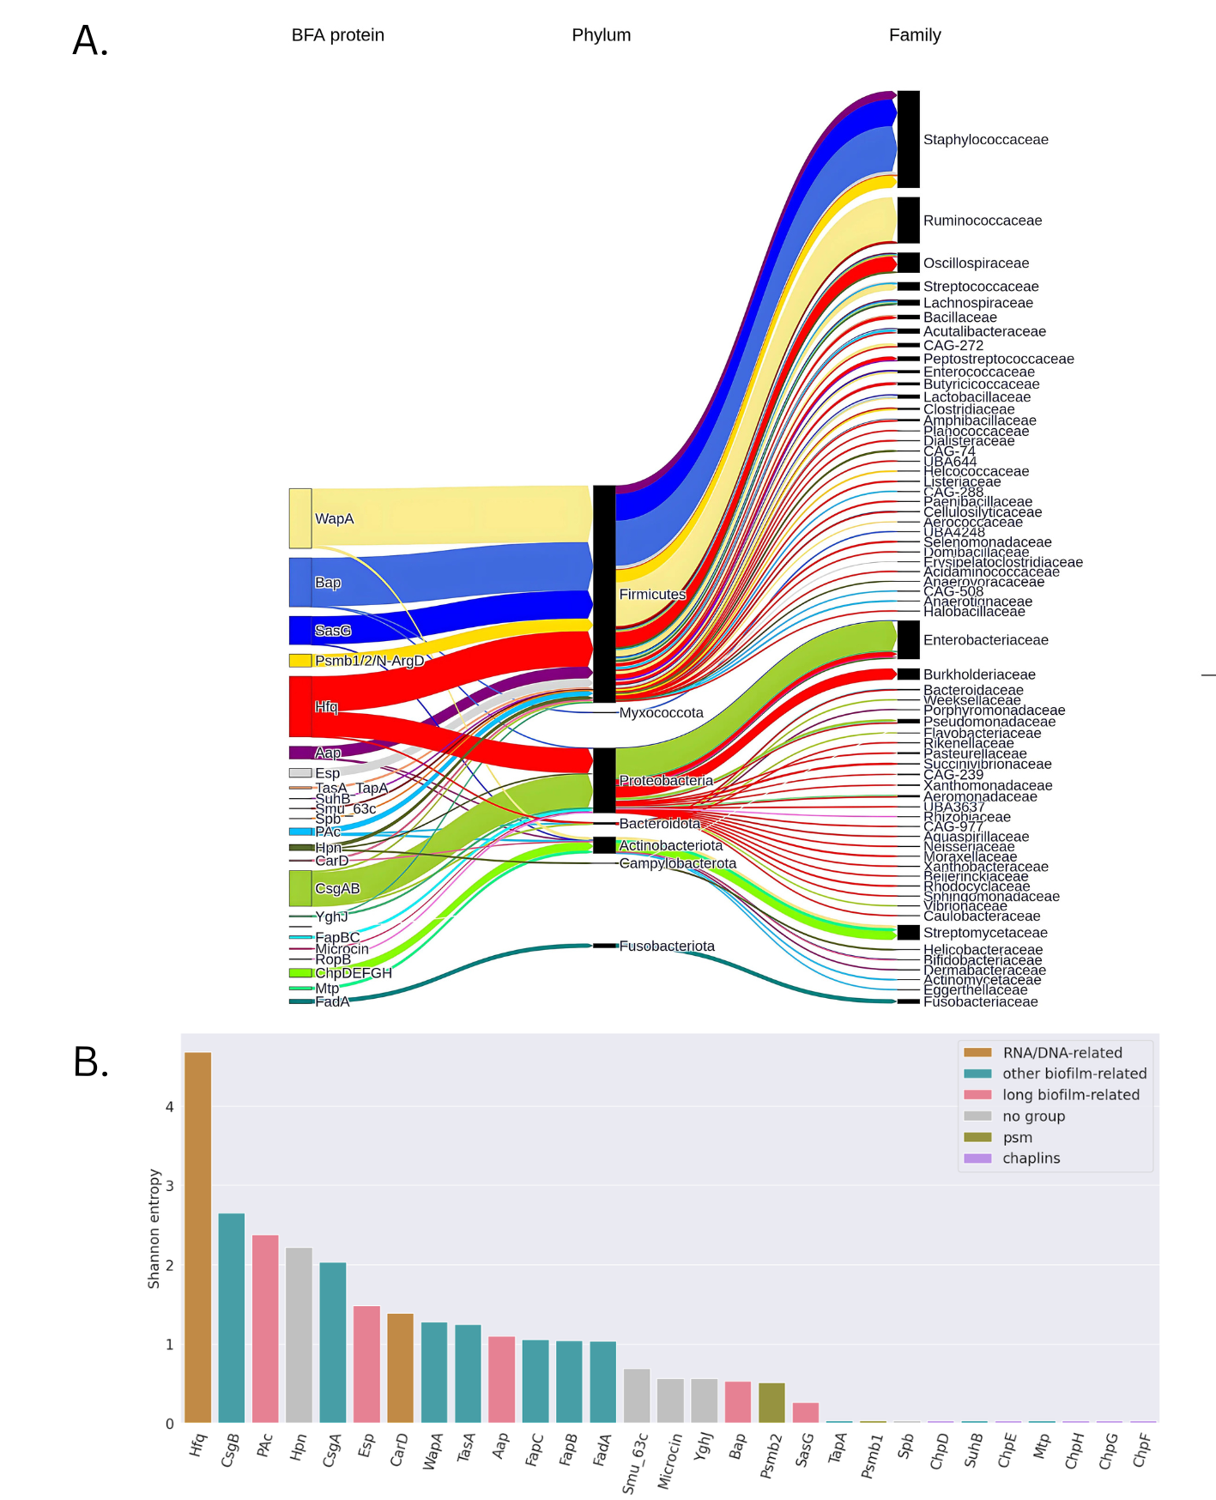

**Fig.1.** Taxonomic distribution of bacterial functional amyloids found in the human gut microbiome proteome.

1. **Conclusions and future work**

Our results provide a rationale for the tentative link between neurodegeneration and gut bacterial functional amyloids. The future research could focus on the potential of bacterial functional amyloids as biomarkers in these disorders. The preprint is available at: https://www.biorxiv.org/content/10.1101/2024.11.26.624671v1.

**Acknowledgements.** We acknowledge the support of EU under grants EDITH No 101083771 (Digital Europe), GEMINI No 101136438 (HORIZON), Meetween No 101135798 (HORIZON), and Teaming Sano No 857533. This work was supported by the National Science Centre, Poland [2019/35/B/NZ2/03997] (MK) and NAWA STER grant of Polish National Agency for Academic Exchange for PhD students (JWW). TK is funded by the National Science Centre, Poland [2023/05/Y/NZ2/00080]. We would like to cordially thank Prof. Pawel P. Łabaj for valuable comments.

**References**

1. D. Otzen, R. Riek. *Functional amyloids*. Cold Spring Harbor perspectives in biology, 11.12, 2019
2. R. P. Friedland, M. R. Chapman. *The role of microbial amyloid in neurodegeneration*. PLoS pathogens, 13.12 2017.
3. H. Braak, U. Rüb., W. P. Gai, K. Del Tredici. I*diopathic Parkinson's disease: possible routes by which vulnerable neuronal types may be subject to neuroinvasion by an unknown pathogen.* Journal of neural transmission, 110(5), 517-536, 2003.
4. C. Wang, C. Y. Lau, F. Ma, C. Zheng, C. *Genome-wide screen identifies curli amyloid fibril as a bacterial component promoting host neurodegeneration.* Proceedings of the National Academy of Sciences, 118(34), 2021
5. A. Fernández-Calvet et al. *Gut microbiota produces biofilm-associated amyloids with potential for neurodegeneration*. Nature communications, 15.1, 2024