**Personalizing Dyslexia Interventions with a Virtual Cognitive Twin Framework**

Suvarna Rekha Chinta

Jagiellonian University, Romana Ingardina 6, Krakow, Poland

[suvarna.rekha.11@gmail.com](mailto:suvarna.rekha.11@gmail.com)

**Keywords:** Virtual Human Twin (VHT), Cognitive Twin, Simulation-based prediction, Multimodal data integration, Precision intervention, Dyslexia

**1. Introduction**

The concept of the Virtual Human Twin (VHT) has primarily focused on physiological and biomedical modelling to advance personalized medicine [2][5]. However, cognitive and neurodevelopmental disorders such as dyslexia and other developmental disorders remain underrepresented in this framework, despite their high prevalence and lifelong impact on education, mental health, and social functioning. Integrating multimodal cognitive and behavioral markers into VHT can expand its scope, enabling more inclusive and personalized supporting and rehabilitative solutions.

**2. Description of the problem**

Current dyslexia research has produced valuable datasets on eye movements, rapid automatized naming, phonological awareness, attentional control, and psychophysiological responses. But these modalities are analyzed in isolation, limiting their predictive value and clinical applicability. There is no fixed computational framework that integrates these heterogeneous markers into a unified model that can simulate, predict, and personalize dyslexia remedial outcomes within the VHT paradigm.

**3. Related work**

Digital twin approaches in medicine are demonstrating the utility of multiscale modelling for organs and diseases (e.g., the Virtual Physiological Human initiative) [4]. Recent computational psychiatry studies also suggest disorder-specific learning signatures in dyslexia and ADHD, supporting the feasibility of latent-state modelling [1][3]. However, no existing studies have systematically adapted such approaches to dyslexia in a way that could feed into VHT platforms.

**4. Solution of the problem**

We propose a preliminary framework for a Virtual Cognitive Twin for dyslexia. Using our dataset of dyslexic and typical readers, including eye-tracking, electrodermal activity (EDA), phonological awareness, and attentional network test (ANT) data, we outline a multimodal integration pipeline. First, features are extracted from each modality to capture cognitive and physiological signatures. Next, machine learning classifiers are applied to identify markers of dyslexic vs. typical reading profiles. Finally, the outputs are conceptualized as latent parameters (e.g., processing efficiency, attentional control, phonological mapping) that could be embedded into a computational model simulating individual reading behavior. This approach provides a demonstrator level contribution to the VHT ecosystem by extending modelling to cognition and learning disorders.

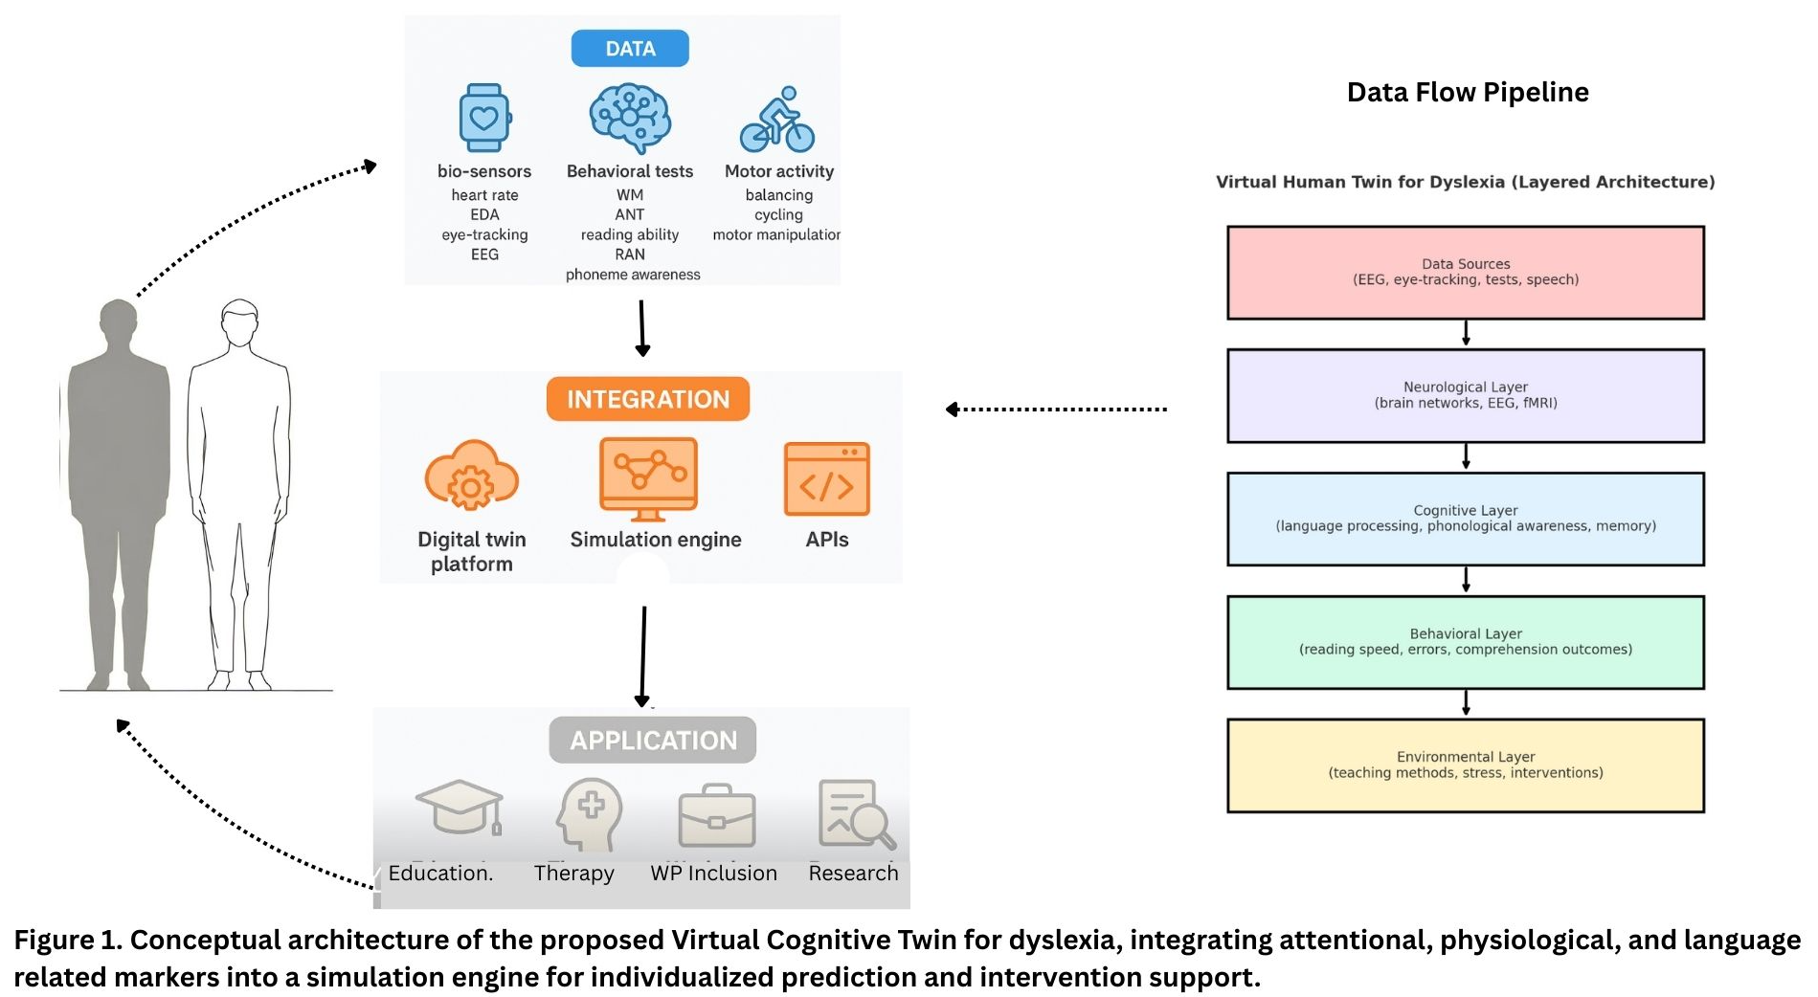

**5. Conclusions and future work**

This work represents an initial step towards incorporating neurocognitive disorders into the Virtual Human Twin paradigm. By integrating multimodal markers of dyslexia into a unified model, we move closer to a platform that not only captures psychophysiology but also cognitive function. Future work will expand datasets, refine classifiers, and test clinical populations, ultimately contributing to personalized intervention strategies for dyslexia and related disorders within the VHT framework.

**References**

1. Gabay, Y., Jacob, L., Mansour, A., & Hertz, U. (2025). Computational markers show specific deficits for dyslexia and ADHD in complex learning settings. *npj Science of Learning*, *10*(1), 38.
2. Kohl, P., & Noble, D. (2009). Systems biology and the virtual physiological human. *Molecular systems biology*, *5*(1), 292.
3. Nissan, N., Hertz, U., Shahar, N., & Gabay, Y. (2023). Distinct reinforcement learning profiles distinguish between language and attentional neurodevelopmental disorders. *Behavioral and Brain Functions*, *19*(1), 6.
4. Trayanova, N. A., & Prakosa, A. (2024). Up digital and personal: How heart digital twins can transform heart patient care. *Heart Rhythm*, *21*(1), 89-99.
5. Viceconti, M., & Hunter, P. (2016). The virtual physiological human: ten years after. *Annual review of biomedical engineering*, *18*(1), 103-123.